Renju lesson on September 28, 2000

Hello everyone!
Welcome to renju lesson. We can begin right away. We are learning i1 opening in these weeks. Today's topic is the 4-i7. We will learn two best 5th moves here.
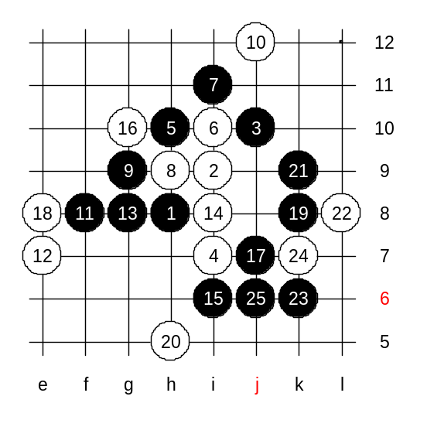
Does anyone of you know which are the best 5th moves? 5-j8 probably loses because of 6-i8, 7- i10, 8-j7 or something. moves 5-h10, 5-i10 or 5-i8 are all good moves. I will teach you 5-h10 at first. Before that, I will also tell you that the result of this 4th move is big black advantage. Some of you may also notice that same pattern can also come from i5 opening. When I taught you the i5 opening, I did not discuss about this pattern because i knew I was going to discuss it under i1 opening. Move 5-h10 - the main 5th move. Indeed, there are some choices for 6th move, but we will check them all.
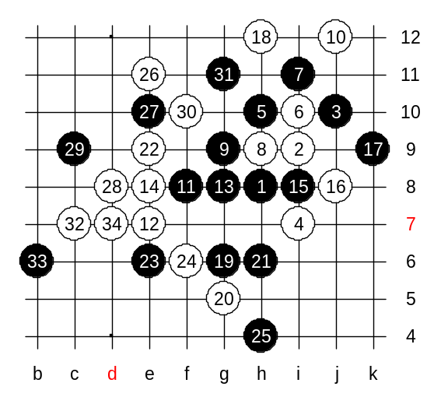
6-i10. White j12 is necessary because if white blocks the three from the other side, then black can begin the attack in upper side and there are no white structures stopping it in any way. This is the beginning of difficult variant, but black wins for sure. First, lets try 14-i8. But the white problem is - there is no good continuation for 16th move. Any white move here seems to lose. Can you offer me any good white move? Maybe 16-g10 is the best resistance (in my opinion), but you can try other move as well. Now, we have the same situation for 18th move - no good moves to choose. Students, please select the 18th move which you think is the best for white and we will test it here. OK, you chose 18-e8. And, as usually, you chose the white move and now you will have to kill it as well. :) Yes, I agree, k8 or k9 should be made first. Black wins easily here. Other 18th moves do not help either.

Another 14 move is much better.
Black win is very long and not so easy. Move 18-h12 is necessary, otherwise easy black win with g11.
19-g6.
Here, white should play 20-g5 because 20-g7 gives easy black win because of 21-h7.
After the class, everyone can self check the variant of 20-g7. If anyone has looked the Russian renju book "Click of Stones", may find a big mistake in next move there: In the book black plays simply 25-h4. The book says that black does not need to play any four before playing to h4 because white attack towards black's forbidden point is no use. Lets check that bug first. I play h4 now. Play 26-e11 first. Black has still a VCF threat. Does anyone of you see it?
Black VCF threat is following: g7, i5, L8, j6, k6, and after that the white stone will be forced to i6. That white stone will block one of the three-lines in that 4x3x3 fork and the point h7 becomes simply 4x3. That what the authors of the book must have counted on. But they missed following white action in their analysis: d8, f10, c7, d7.
Now, white wins.

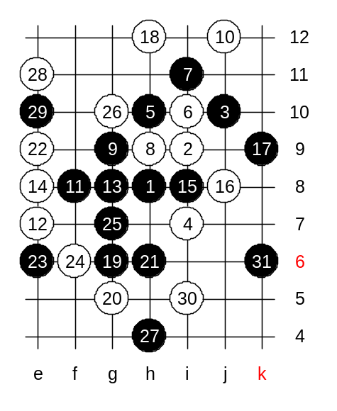
Black has to play a four to h7 before playing to h4. That will fix the bug.
Now, white cannot have any counter-attack. So, white has to continue in passive defense. The best defense is 28-e11 and 30-i5. Point h7 is forbidden 4x3x3 now. Black continues development with 31-k6. Black's idea is obvious - to force white stone to i6 which would make point h7 legal 4x3. Therefore, white has no other good moves than simply playing to h7. Black wins here. Do you know how? You will know, because it will be your homework for this week. This will be the advanced level homework.

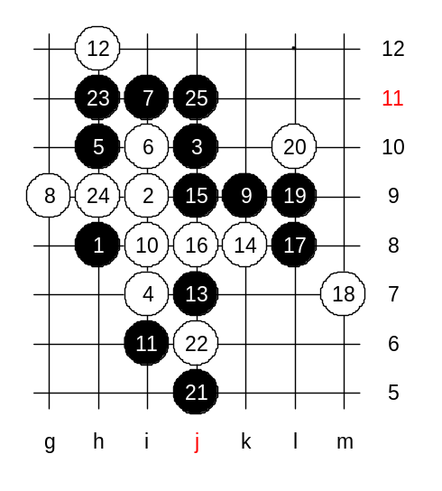
Another 8th move - g9. Here black wins with powerful positional attack.
Moves 10-i8 and 12-h12 are the strongest. If white does not play a four first then black will self play to i8 in next move. Who can guess the next black move?
In fact, here is only one good move. From move 19, black plays a series of positional attacking moves. All following white moves are practically forced. After nice h11 black wins.

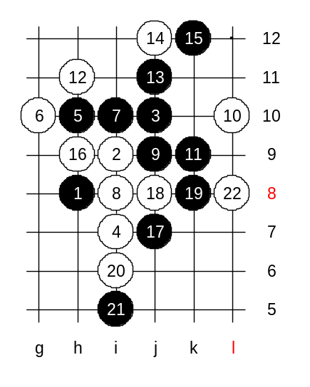
The last position for today. It will include the medium level homework. We change the 6th move as we proved the black win after 6-i10 already. We will study 6-g10 now. Move 8-i8 is one of the strongest defense moves. Without knowing theory, most people would fail here attacking as black. Moves 9 and 11 are very hard to guess.
10-L10!
12-h11!
With this 19th move, black prepares a powerful attack. After any 20th move black has winning attack. Move 20-L8 is the strongest defense, but still loses, too. Now, black wins. How? You will tell me, because this will be your homework, too. We can announce it as medium level homework. Before sending me the answer, be careful and double check everything. Sometimes people think the homework is too easy and they become careless and miss something.
I asked several people if they solved the medium level homework last week. They said, no need even look at it, too easy, i10 and f10 gives easy 3x3. But they missed black VCF threat after this. They missed because they underestimated the renju problem. Those who are going to try advanced level homework, please try this homework, too. This time the medium level homework is a bit more difficult than last week homework. The class is over now. Thank you all for joining, I hope to see you all again next week.

